

|  |  |
| --- | --- |
| [NCC Global Assignment] | |
| Student Name: | [Lynn Myat Bhone Htut] |
| NCC Education ID Number | [P00200290] |
| Name of Center | KBT001 - KBTC University |
| Unit | [Designing and Developing a Website] |
| Course Title: | Level 4 Diploma in Computing (L4DC) |
| Date: | [8 Feb 2023] |

Table of Contents

Introduction 2

Task 3 2

3.1 Validate with W3C 2

3.2 How the site performs for people with disabilities 6

3.3 Testing on two different browsers 7

3.4 Problems and recommendations for how these could be fixed 24

Task 4 24

4.1 Three different plugin that I used in my website 24

4.2 Web application development tools 25

4.3 Two benefits to RCC of using web services 25

4.4 Further development of the website 26

Conclusion 26

References 27

# Introduction

Welcome to “GreenHill” Retail Camping Company (RCC), a company dedicated to providing high-quality camping gear for outdoor enthusiasts. As a creator, I am proud to introduce my beautifully designed website with a user-friendly interface. The website is dominated by a soothing green color, which is inspired by the beauty of nature. We aim to provide a seamless online shopping experience for all your camping needs. Browse our collection today and start planning your next adventure!.

# Task 3

## 3.1 Validate with W3C

The World Wide Web Consortium (W3C), which is the main international standards group for the Web, is a group of people who work together to make open standards. And it is a group that doesn't make money.

Web technology standardization is W3C's focus. The W3C is a founding member of OpenStand (The Modern Paradigm for Standards), a global effort to transform how people create, deploy, and use technology for humanity. (Web.lu, 2013)

I have used W3C validator to check all of my pages. All of my mistakes have now been fixed. Here are some screen shots from w3c validators...

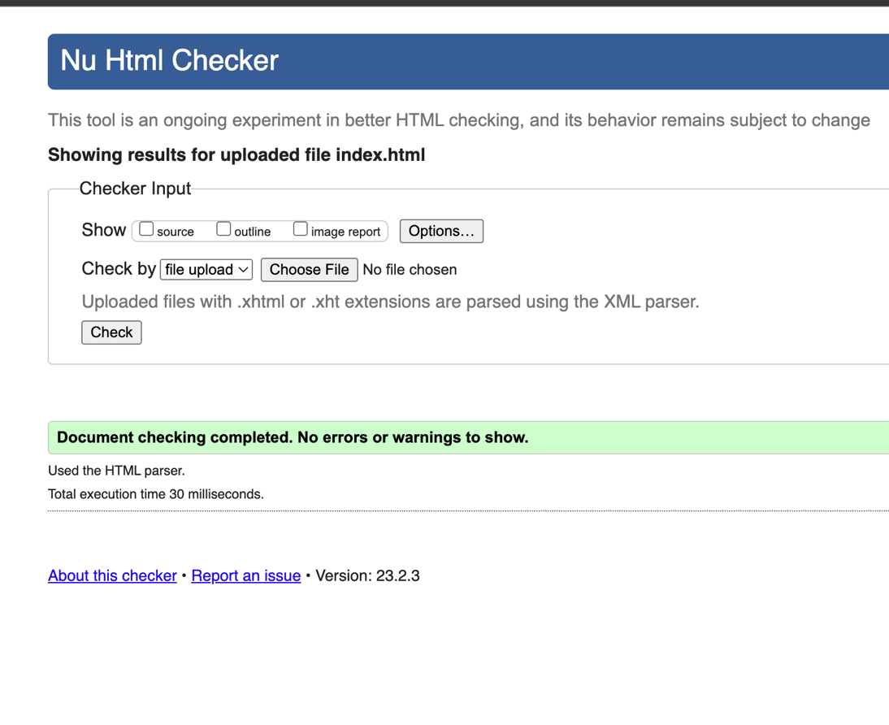

*Figure 1: Validation Home Page*

1.Validation for Index Page

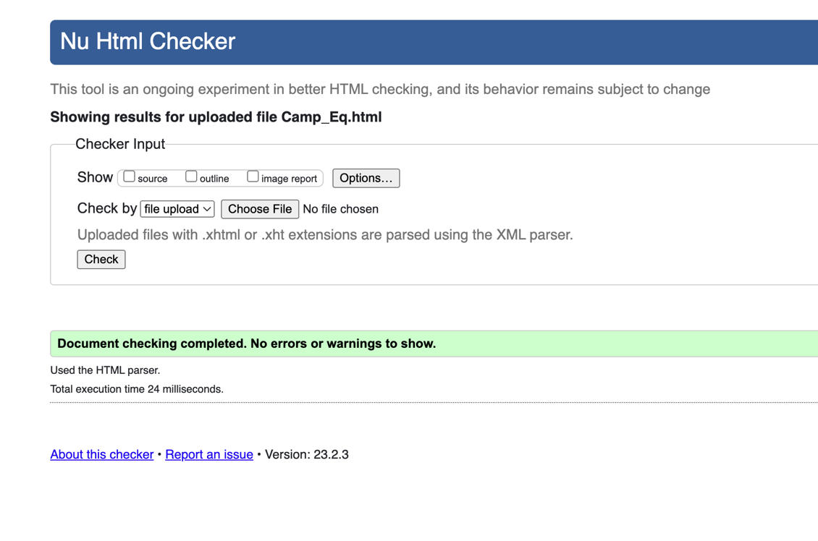

*Figure 2: Validation Camping Equipment Page*

2.Validation for Camping Equipment

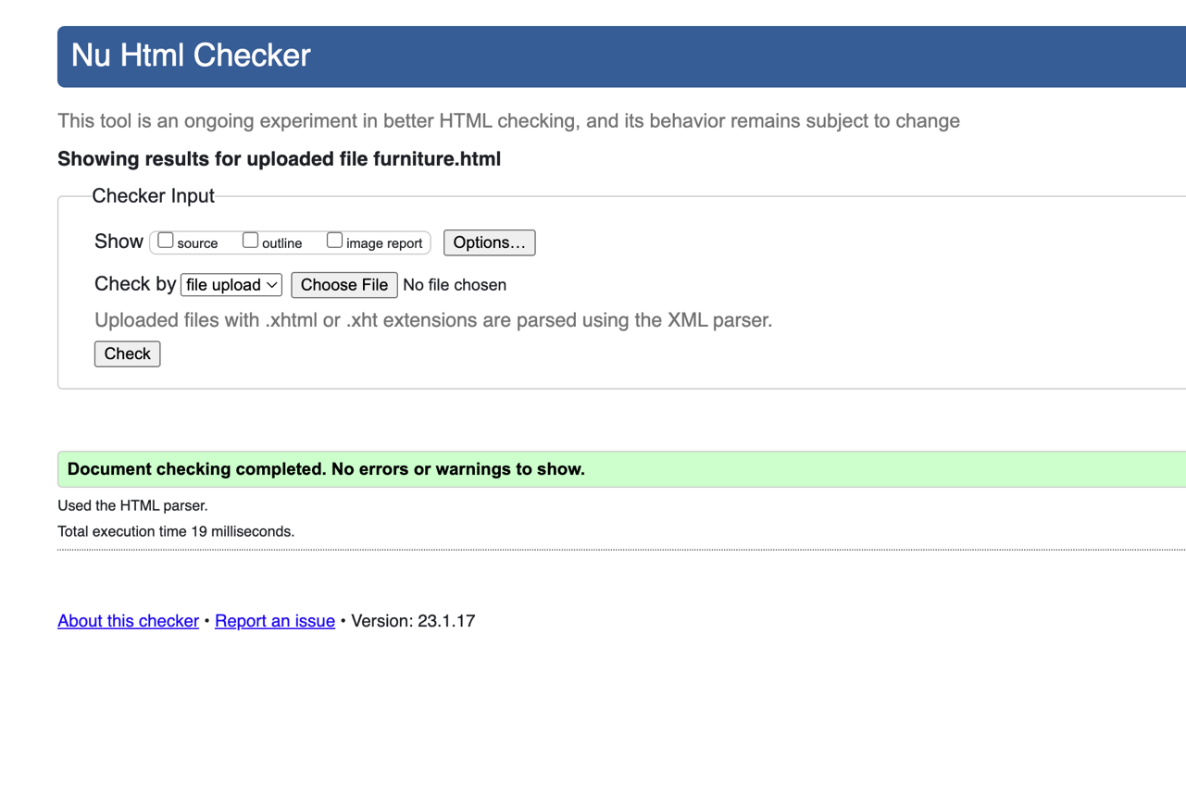

*Figure 3: Validation Furniture Page*

3.Validation for Furniture Page

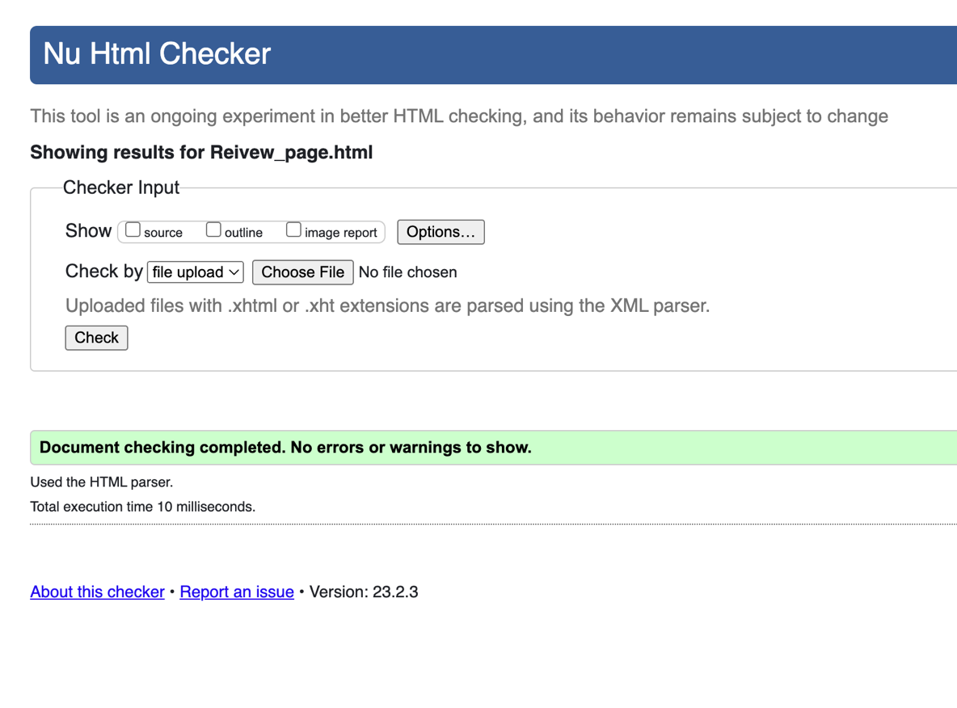

*Figure 4: Validation Review Page*

4.Validation for Review Page

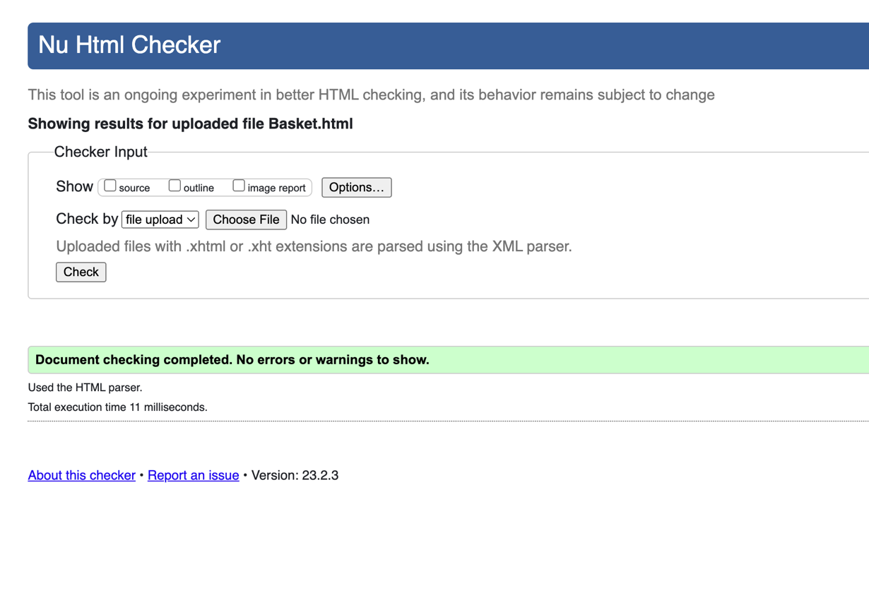

*Figure 5: Validation Basket Page*

5.Validation for Basket Page

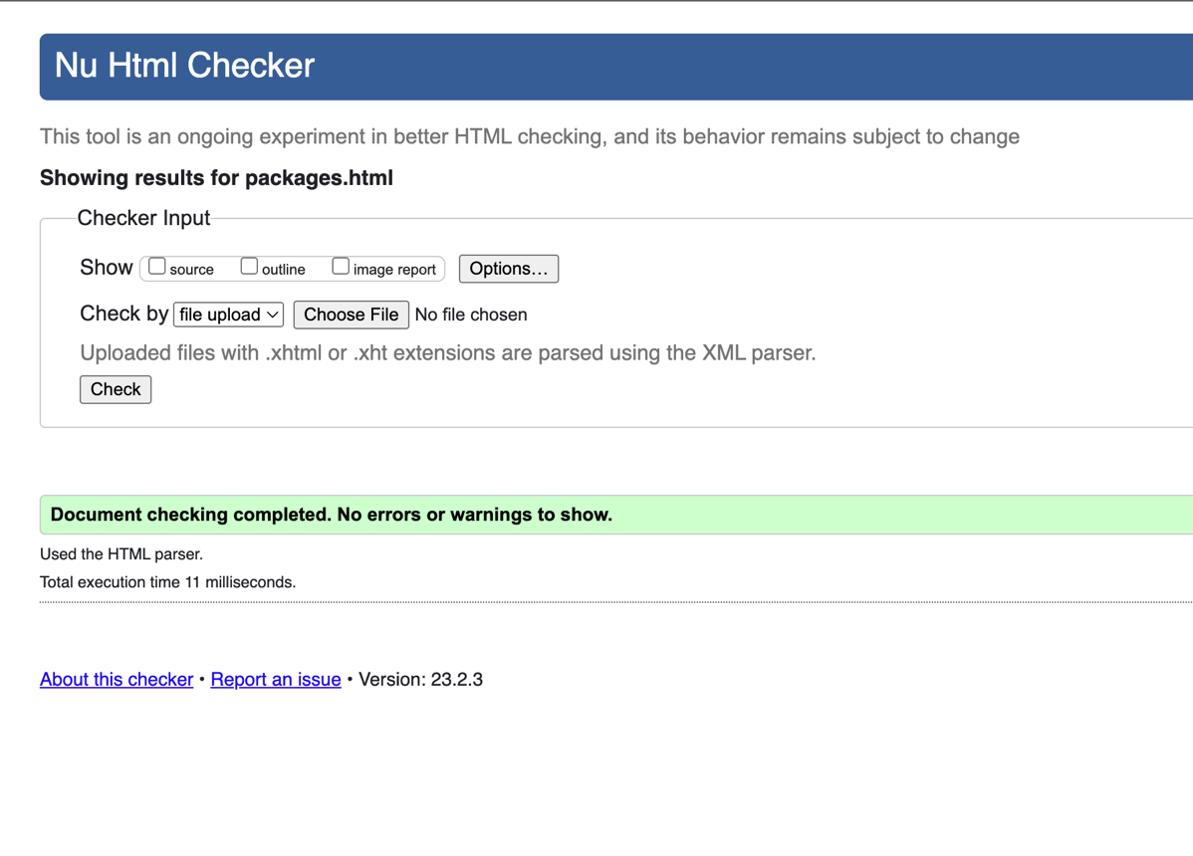

*Figure 6: Validation packages Page*

6. Validation for Offers and Package page

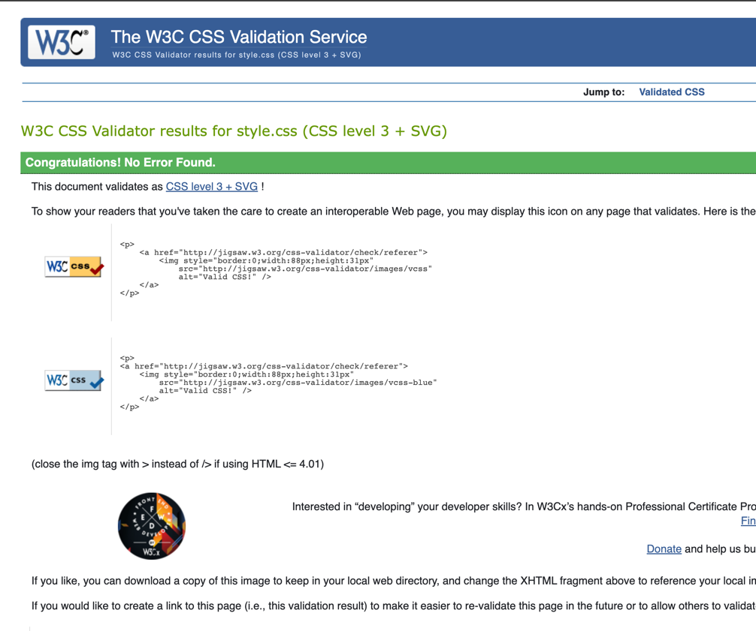

*Figure 7: Validation Style.css*

7. Validation for Style (CSS)

## 3.2 How the site performs for people with disabilities

I used a relevant screen reader to check if the site was easy to use for people with disabilities. On the website, I used a big font style and more space between the letters to help people who have weak vision , I used a big font style and more space between the letters to help people who have weak vision. For those people, the button is also much bigger and clearer and uses a green color to get highlight. (Ślusarczyk, 2021)

## 3.3 Testing on two different browsers

Chrome and Firefox, which are the two most popular browsers, were used to test my site. Both browsers work just as well for most of the functions. But the Firefox browser shows the option tags in a slightly grey color and provide country flag , while the Chrome browser shows them in a white color. In the Firefox browser, the option that was chosen is shown as "pure grey ," . In Chrome, the option that has been chosen is shown in grey, while the text is white.

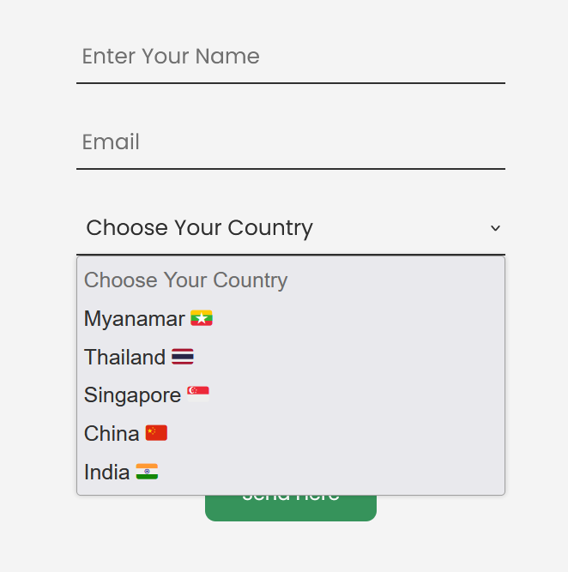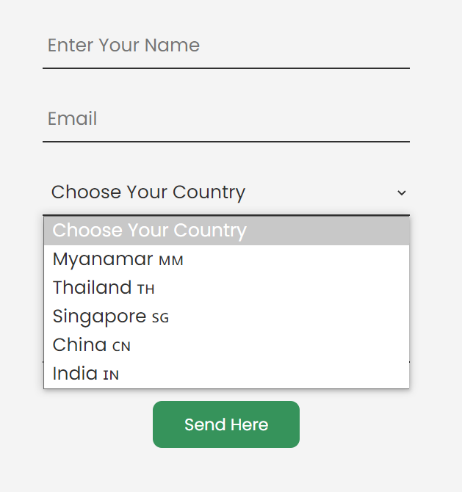

*Figure 8: Firefox Browser Figure 9 : Chrome Browser*

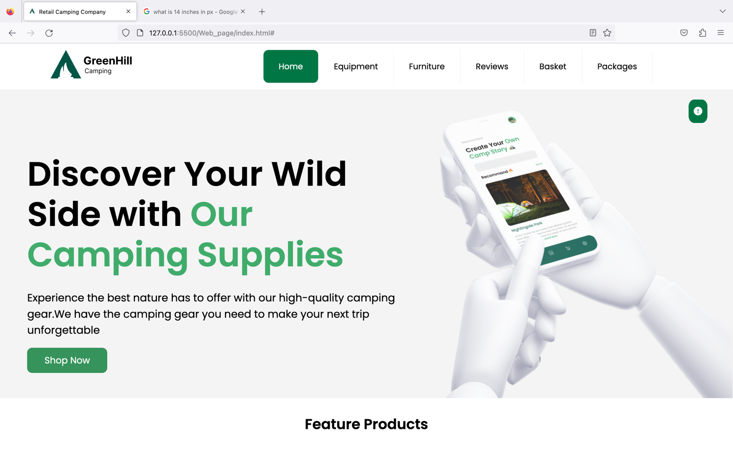

*Fig 10 : Test on Firefox*

Firefox (1344 x 756) – Home page ( Landing Page )

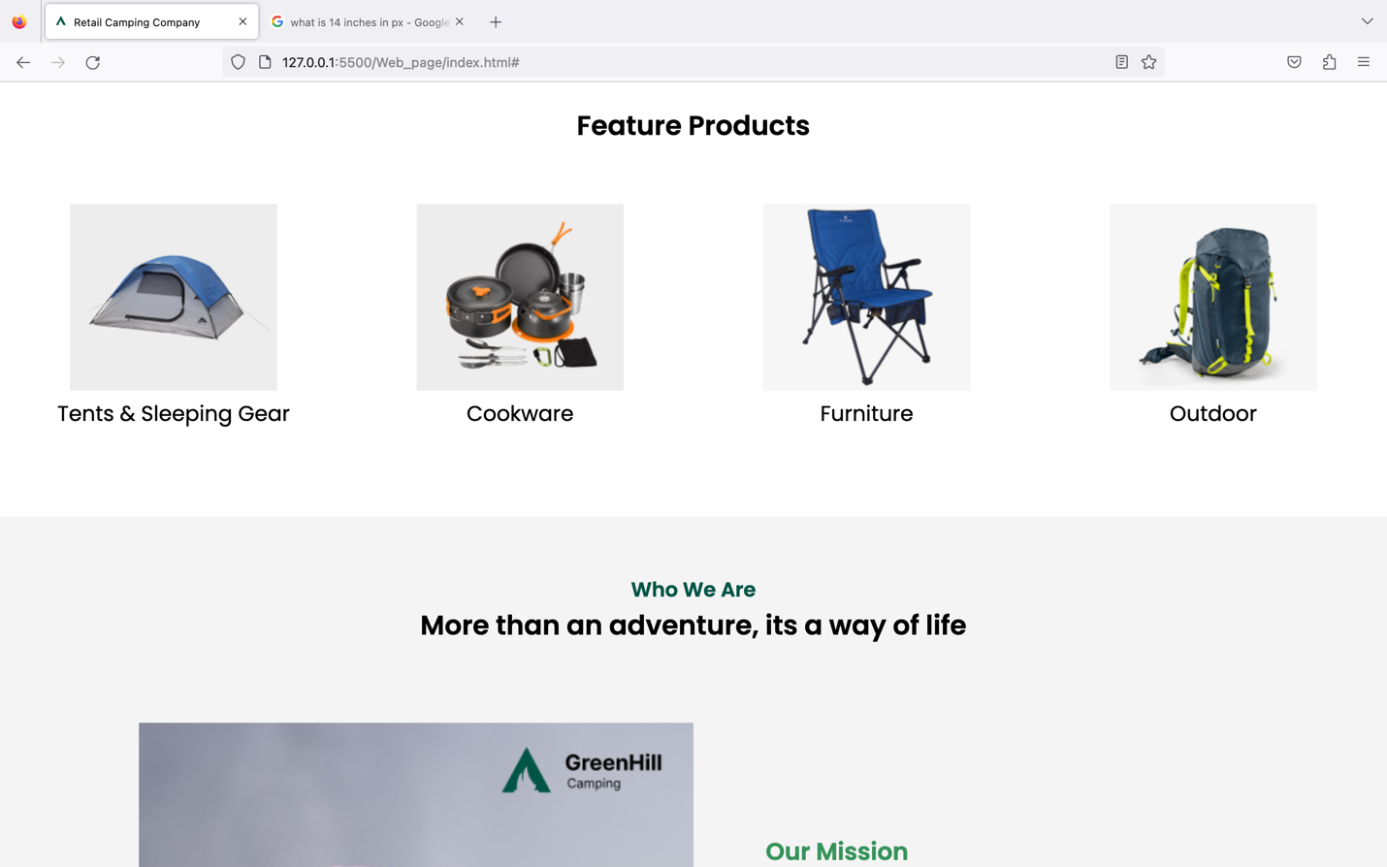

*Fig 11 : Test on Firefox*

Firefox (1344 x 756) – Home page ( Feature Page with hover effect )

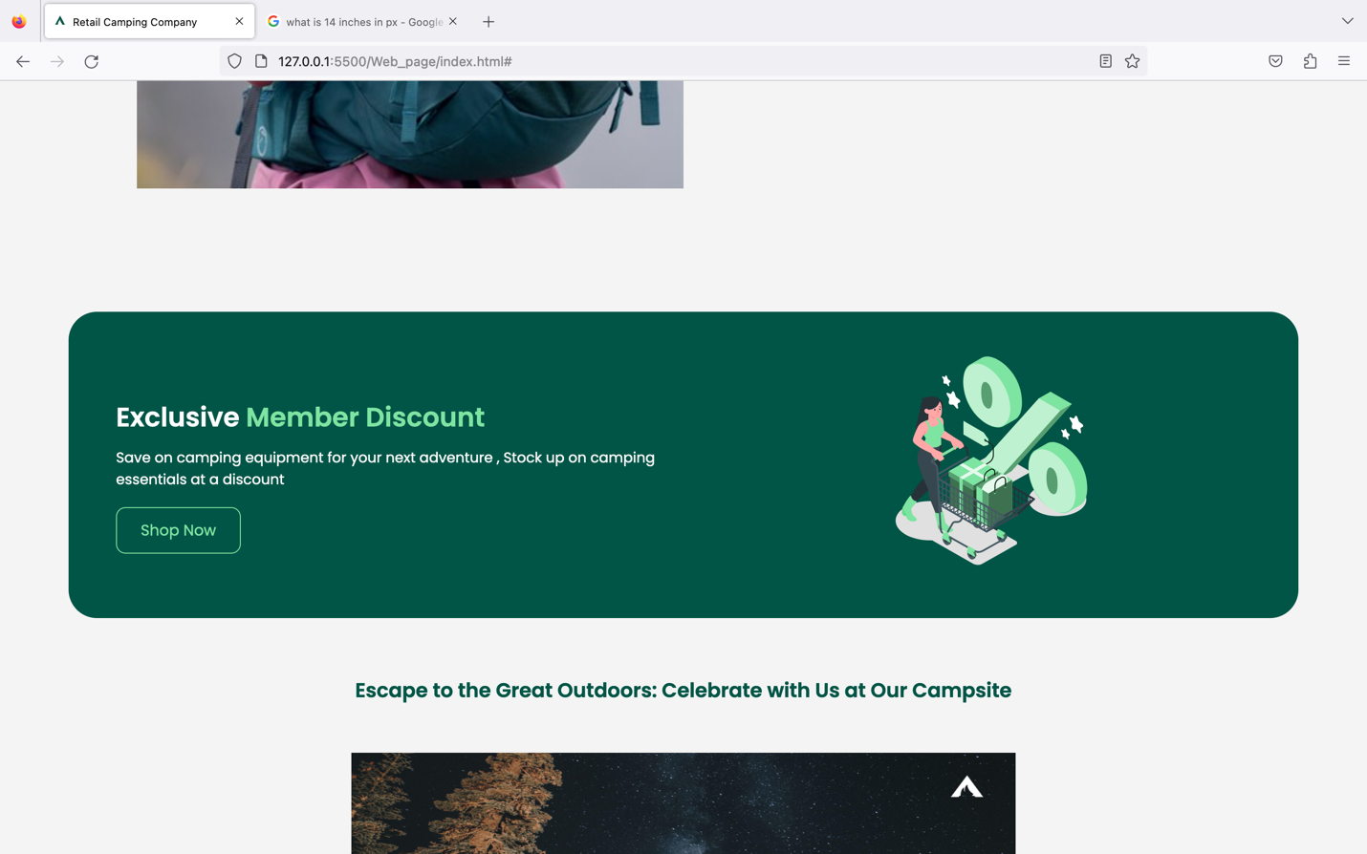

*Fig 12 : Test on Firefox*

Firefox (1344 x 756) – Home page ( Member Discount section link with Shop Now btn )

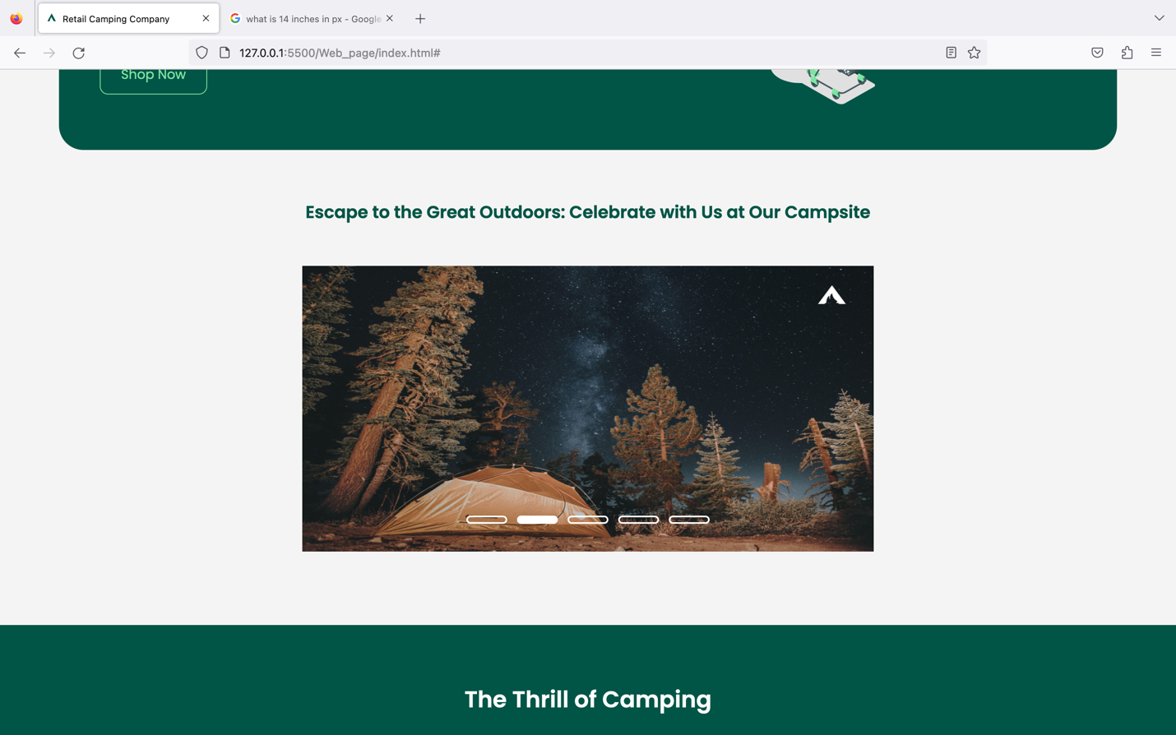

*Fig 13 : Test on Firefox*

Firefox (1344 x 756) – Home page ( Slideshow section )

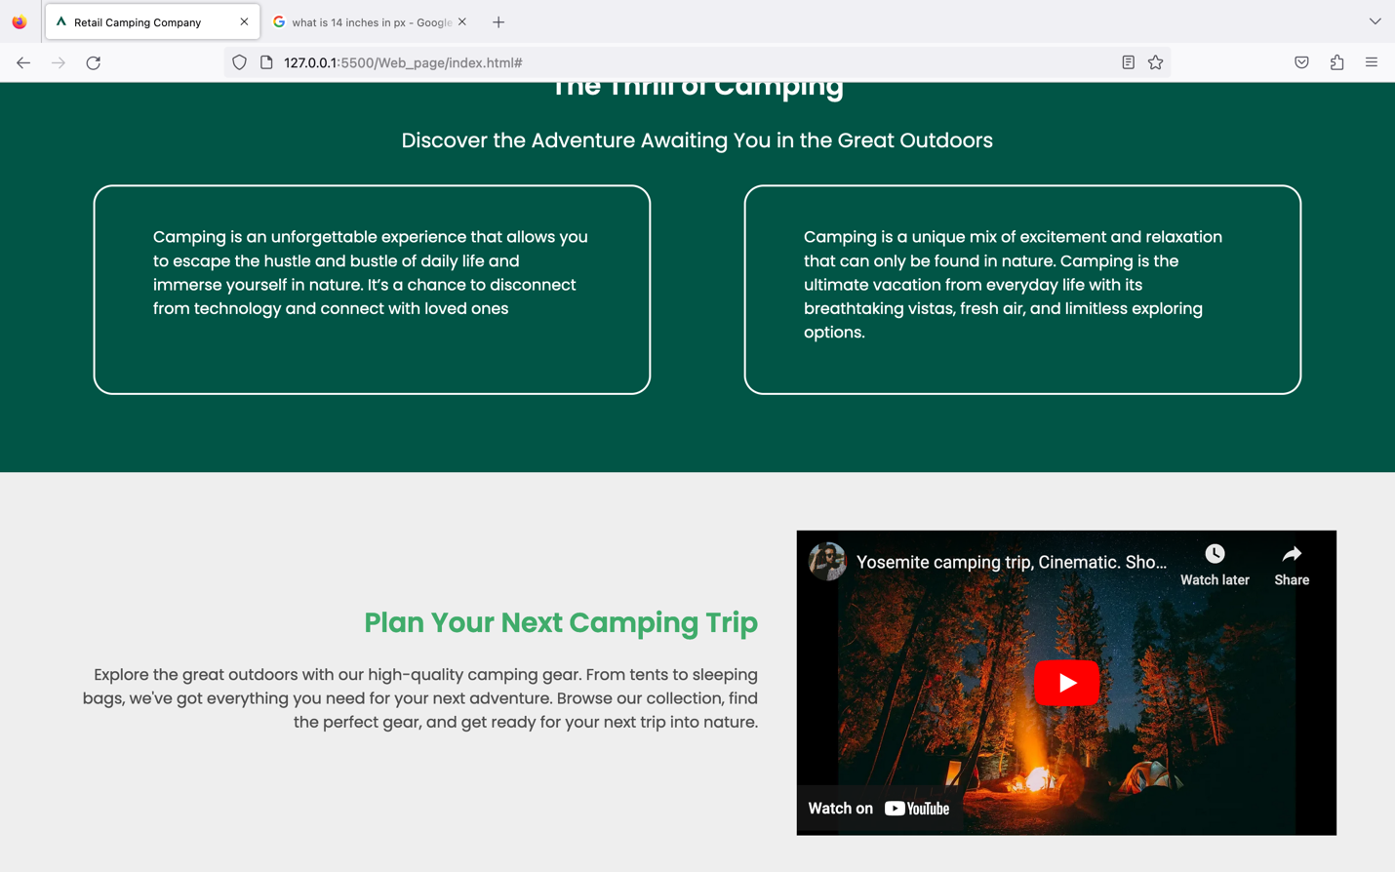

*Fig 14 : Test on Firefox*

Firefox (1344 x 756) – Home page ( YouTube Plugin )

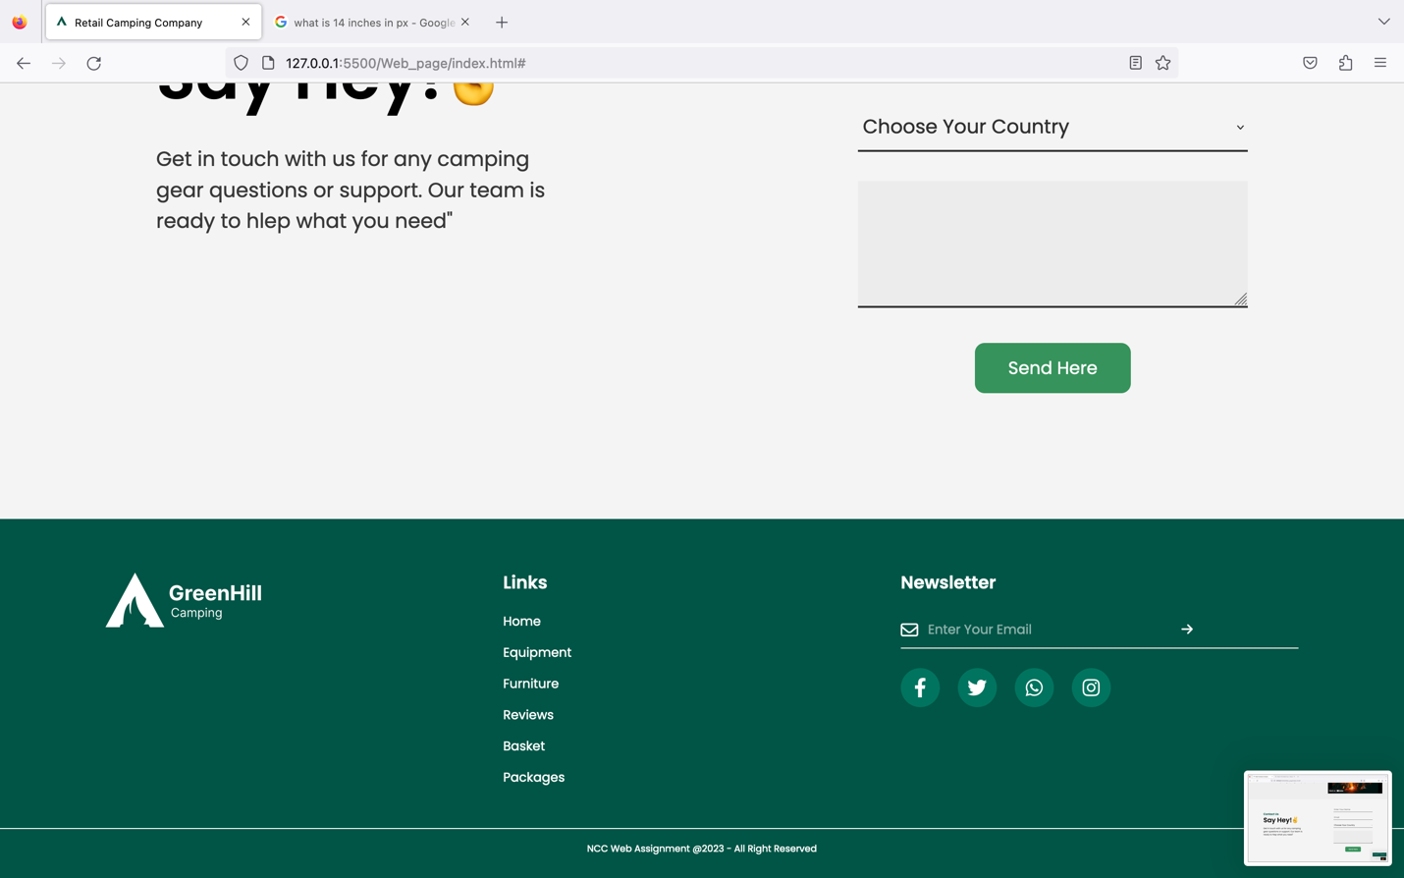

*Fig 15 : Test on Firefox*

Firefox (1344 x 756) – Home page ( Footer Section with social media link )

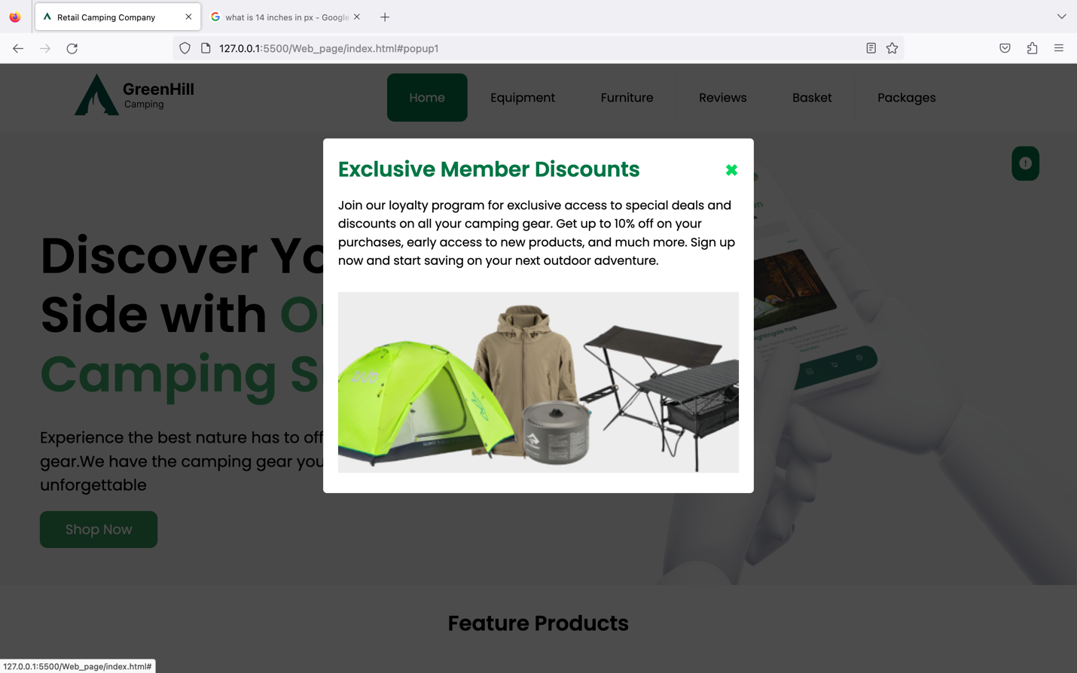

*Fig 16 : Test on Firefox*

Firefox (1344 x 756) – Home page ( Pop-up)

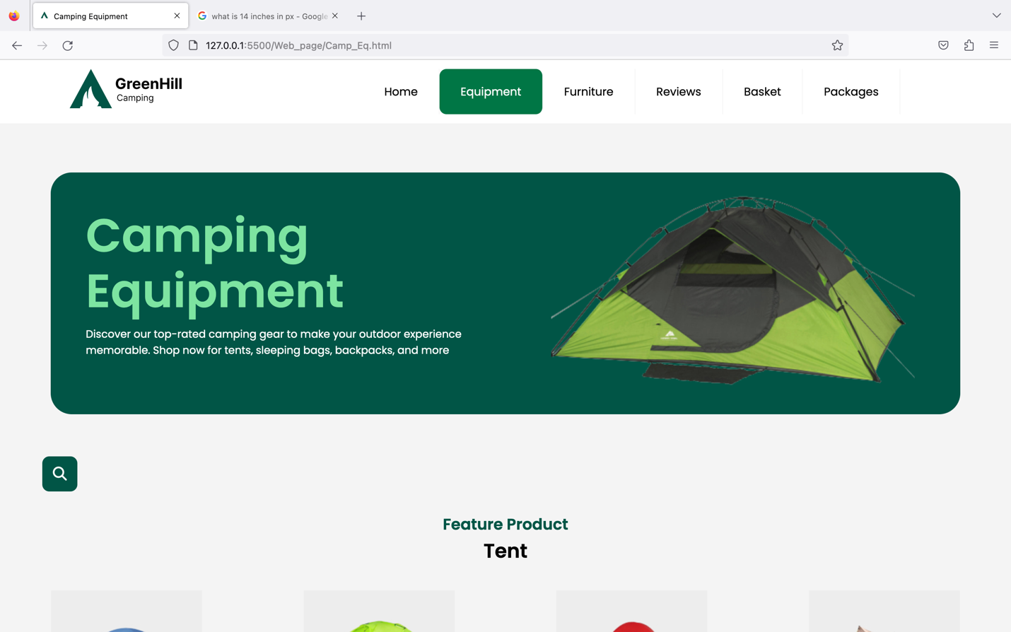

*Fig 17 : Test on Firefox*

Firefox (1344 x 756) – Equipment page ( Equipment )

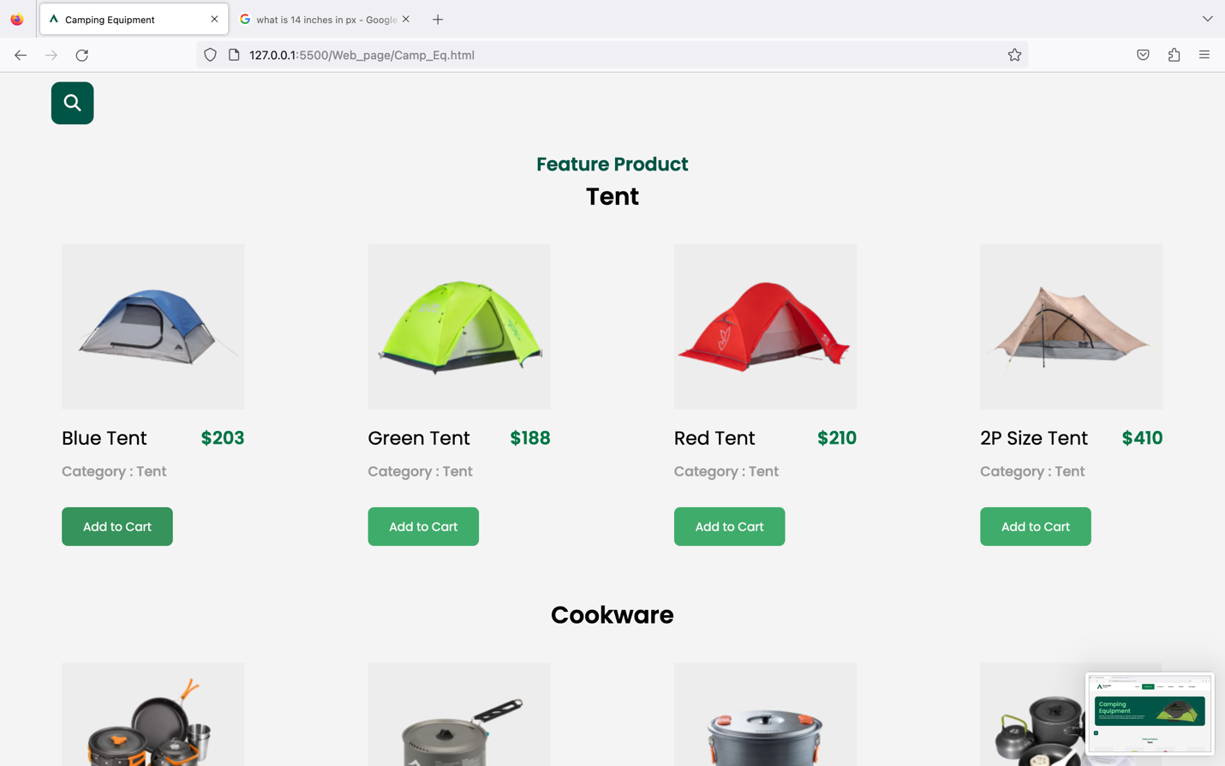

*Fig 18 : Test on Firefox*

Firefox (1344 x 756) – Equipment page ( catalogue of Camping Equipment )

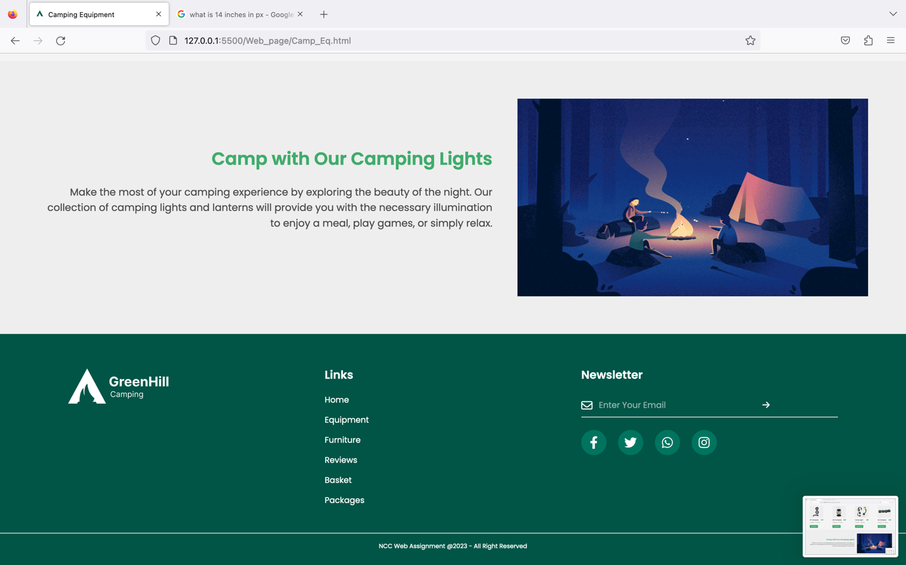

*Fig 19 : Test on Firefox*

Firefox (1344 x 756) – Equipment page ( GIF Plugin )

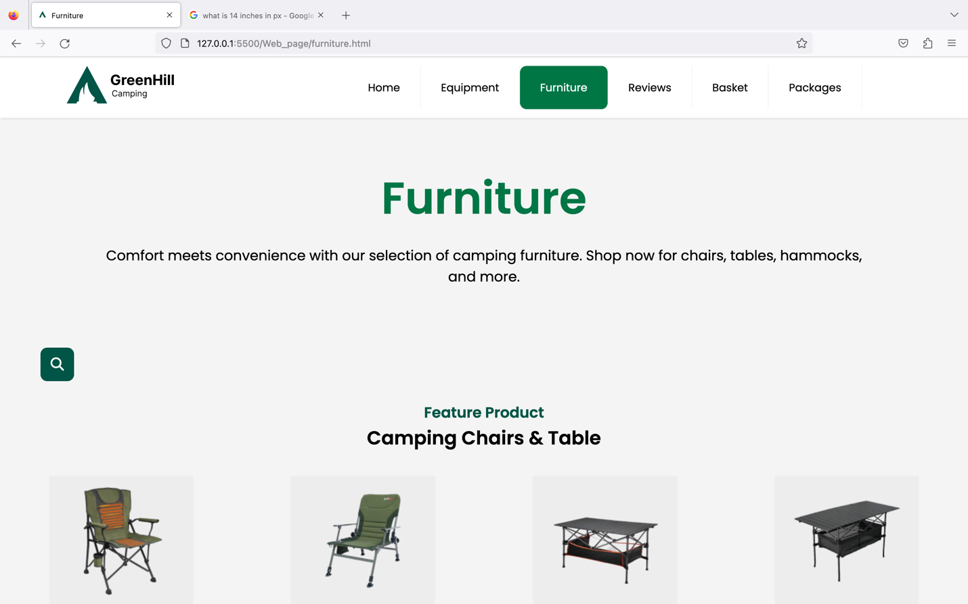

*Fig 20 : Test on Firefox*

Firefox (1344 x 756) – Furniture page ( Feature Product with search bar animation )

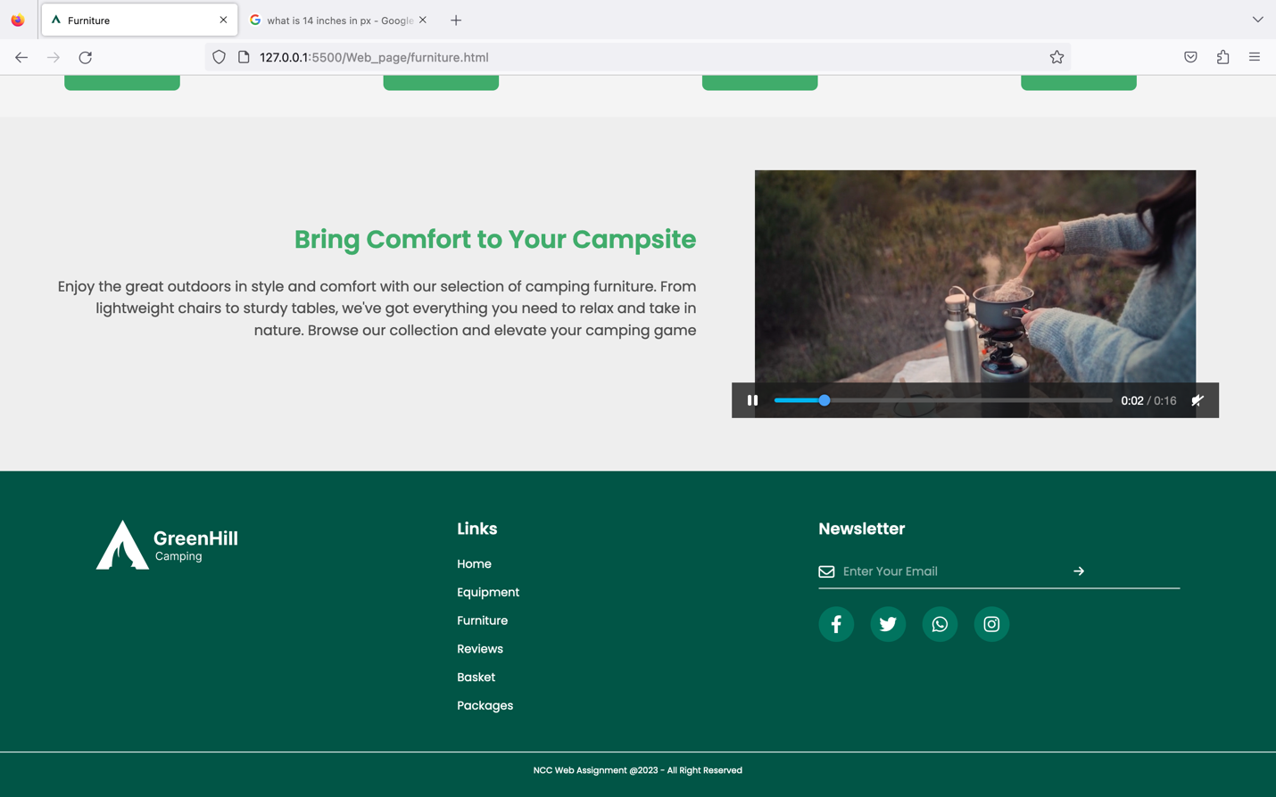

*Fig 21 : Test on Firefox*

Firefox (1344 x 756) – Furniture page ( Video Plugin )

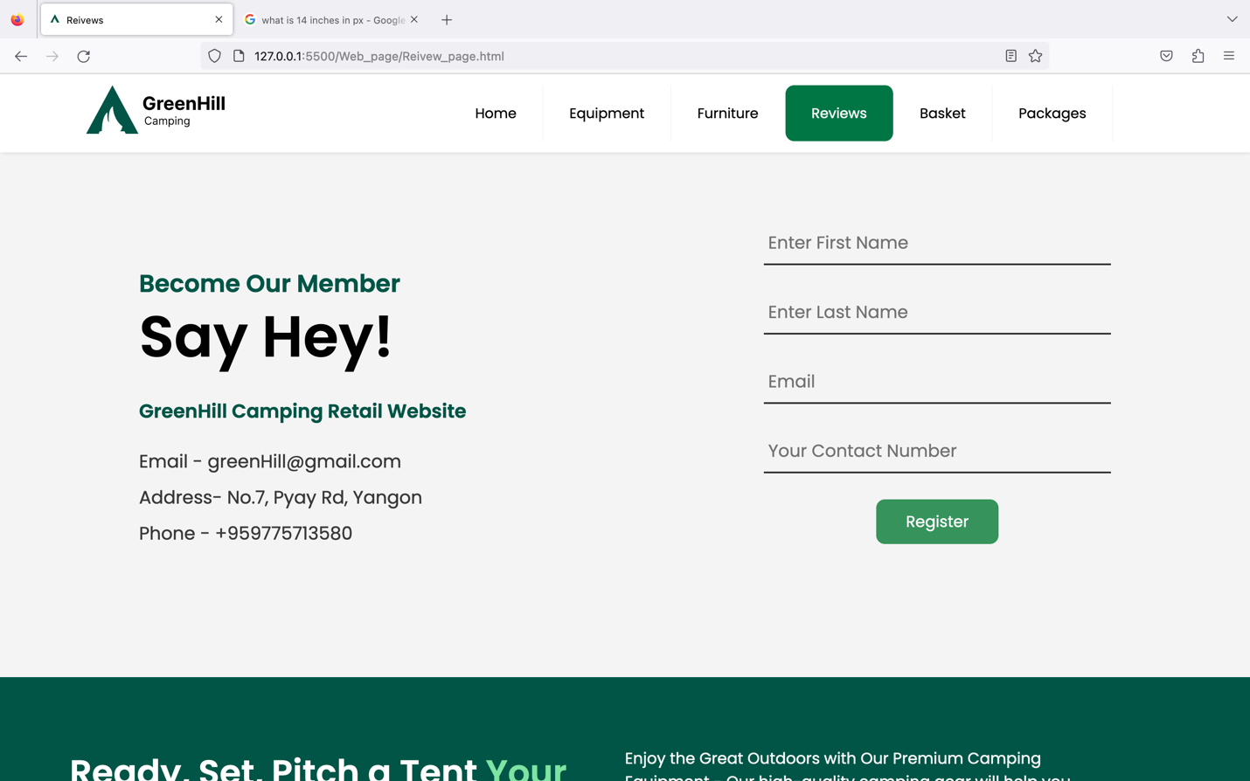

*Fig 22 : Test on Firefox*

Firefox (1344 x 756) – Review page ( Register to become with our member )

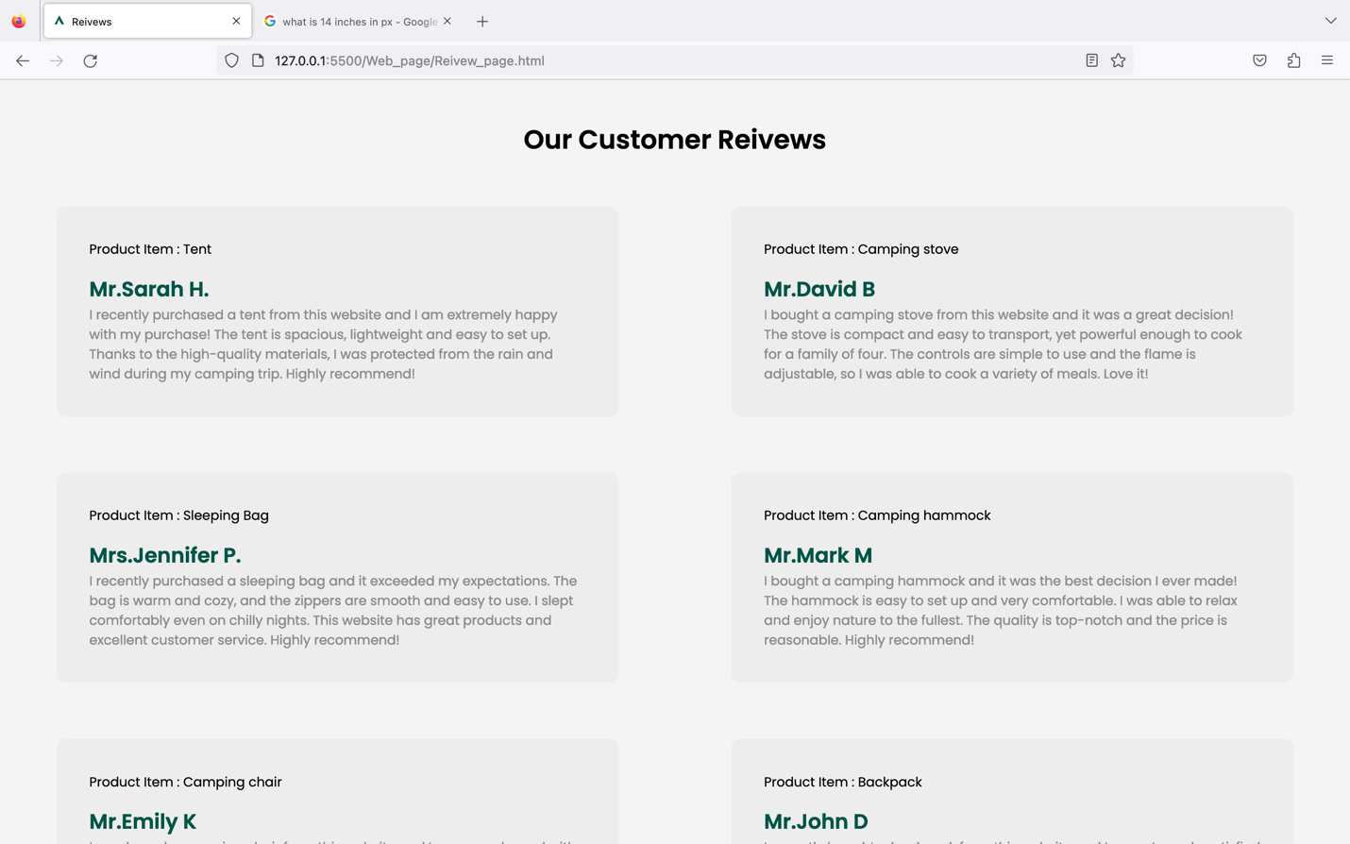

*Fig 23 : Test on Firefox*

Firefox (1344 x 756) – Review page ( Our Customer review )

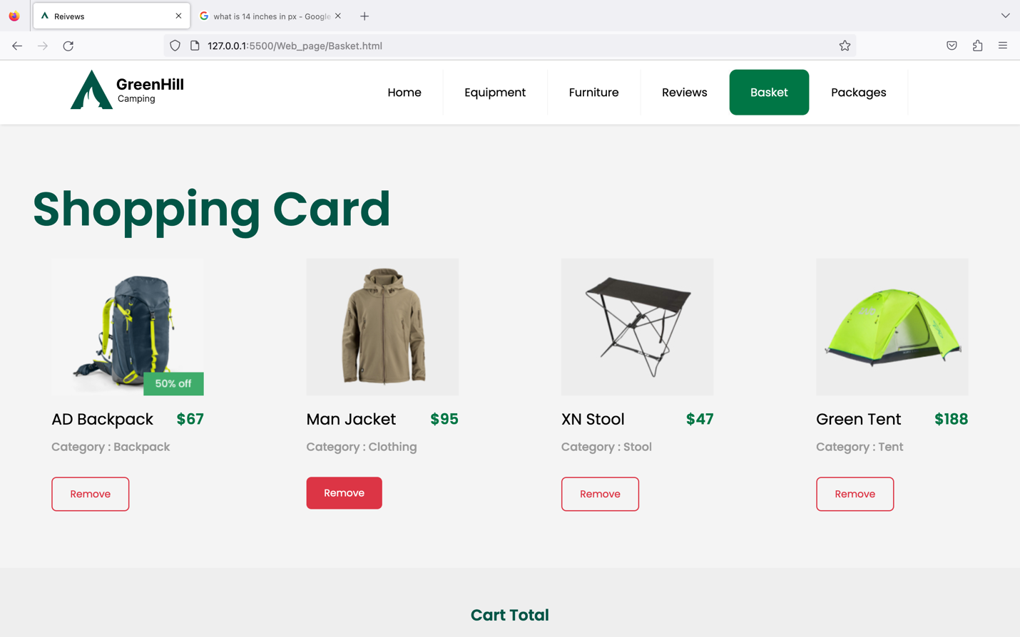 *Fig 24 : Test on Firefox*

Firefox (1344 x 756) – Basket page ( Product item that are in basket )

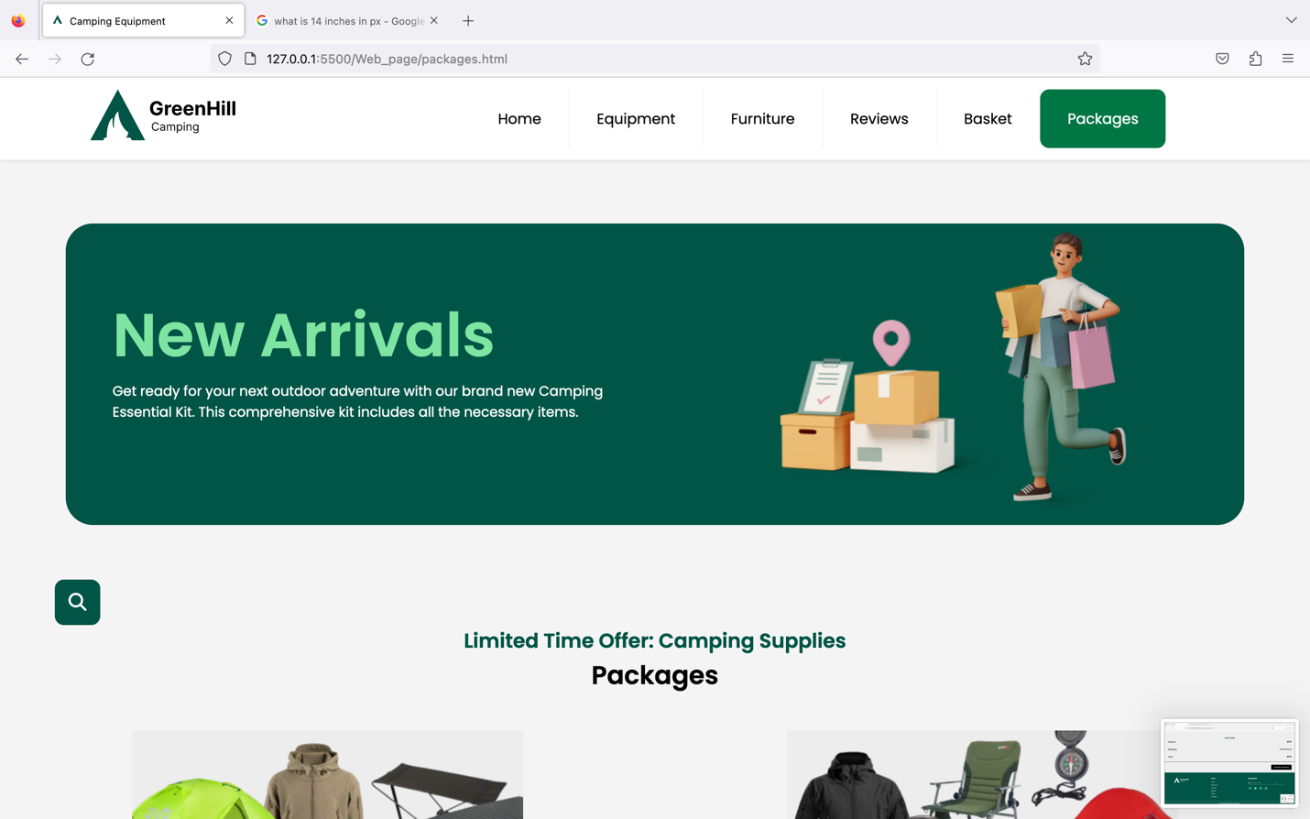

*Fig 25 : Test on Firefox*

Firefox (1344 x 756) – Offers and Packages page ( Packages )

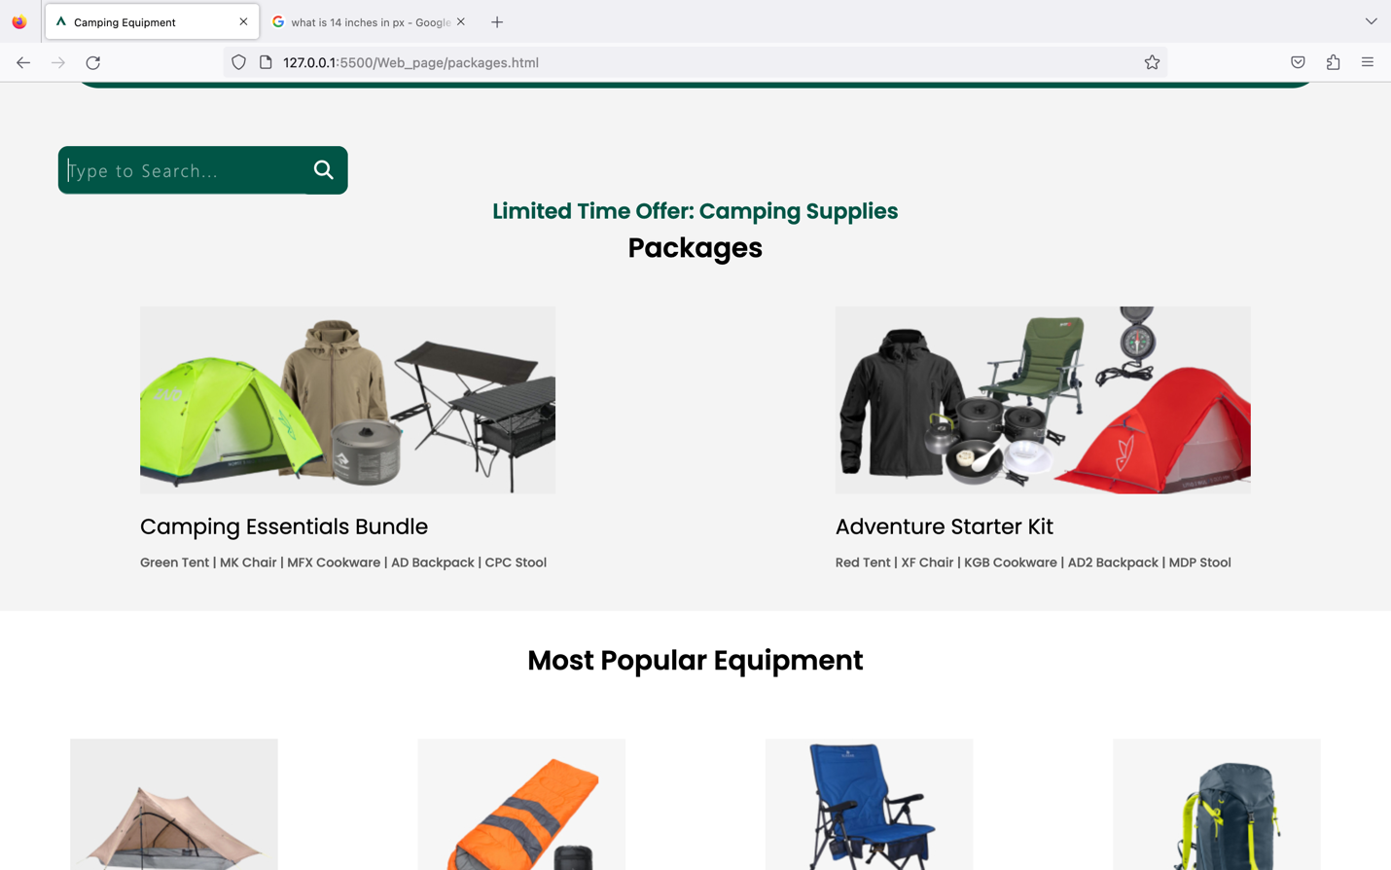

*Fig 26 : Test on Firefox*

Firefox (1344 x 756) – Offers and Packages page ( Packages and discount product )

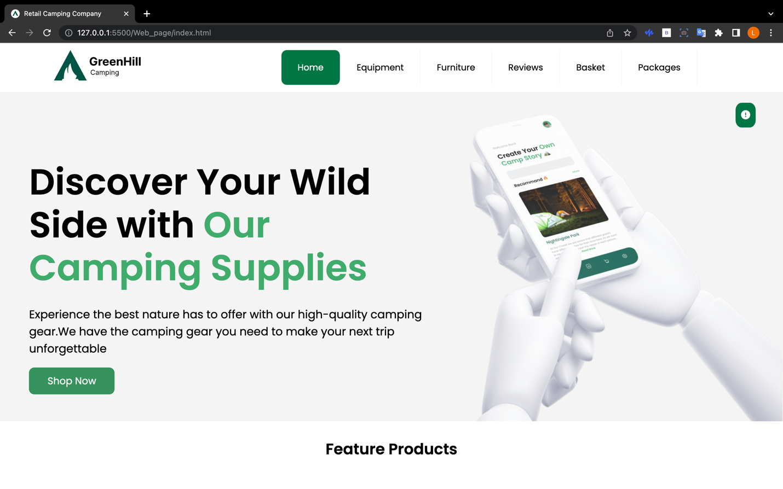

*Fig 27 : Test on Chrome*

Chrome (1344 x 756) – Home page ( Landing Page )

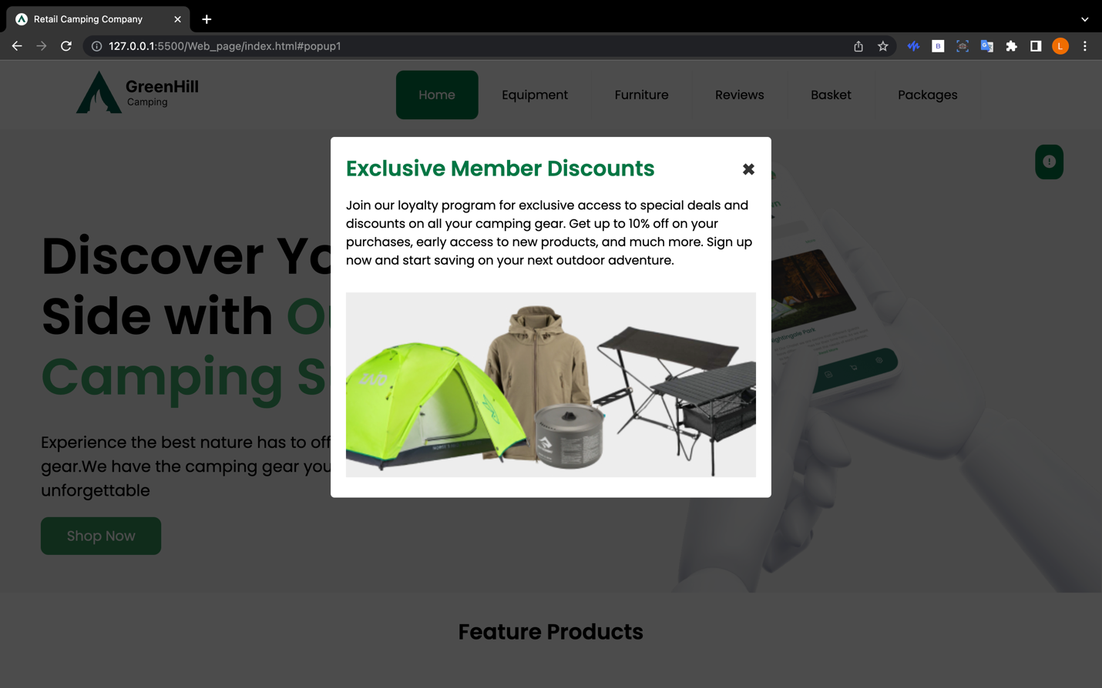

*Fig 28 : Test on Chrome*

Chrome (1344 x 756) – Home page ( Pop-up )

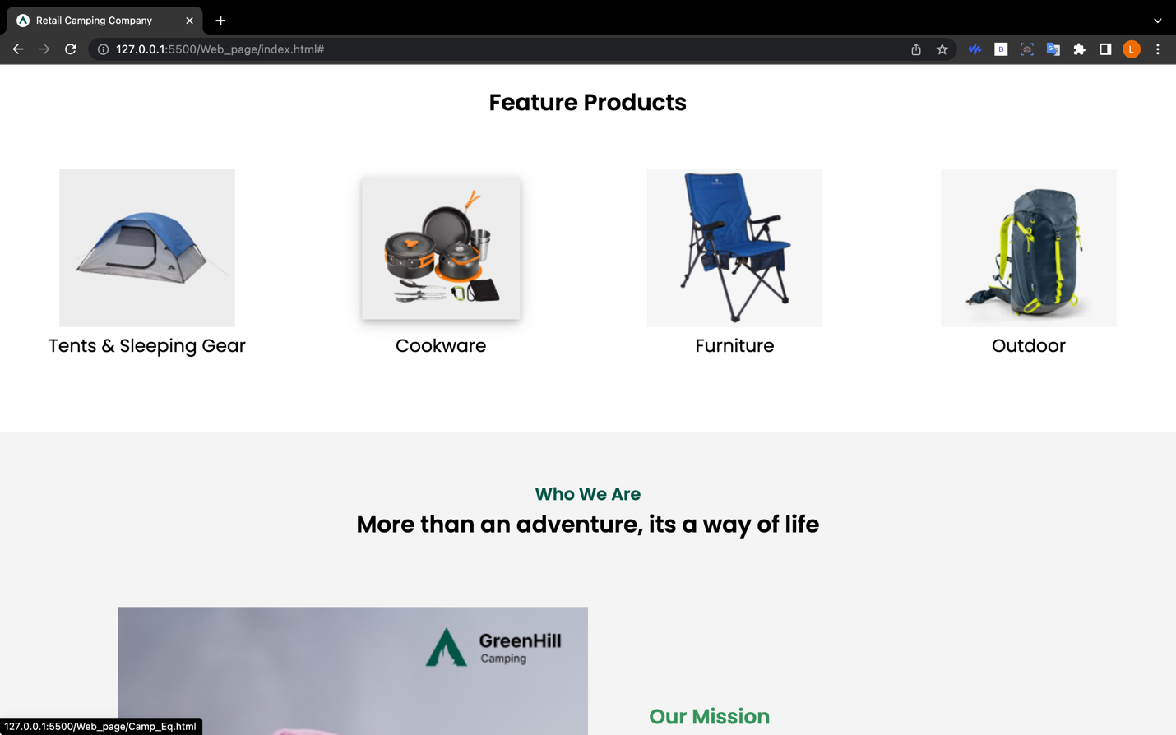

*Fig 29 : Test on Chrome*

Chrome (1344 x 756) – Home page ( feature product )

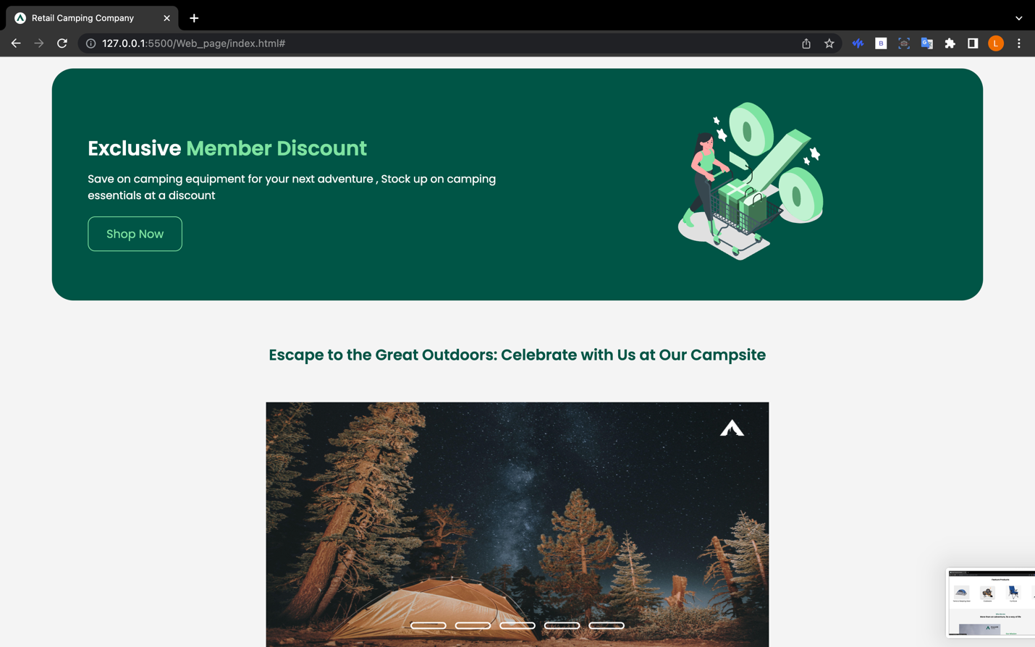

*Fig 30 : Test on Chrome*

Chrome (1344 x 756) – Home page ( member discount and slideshow )

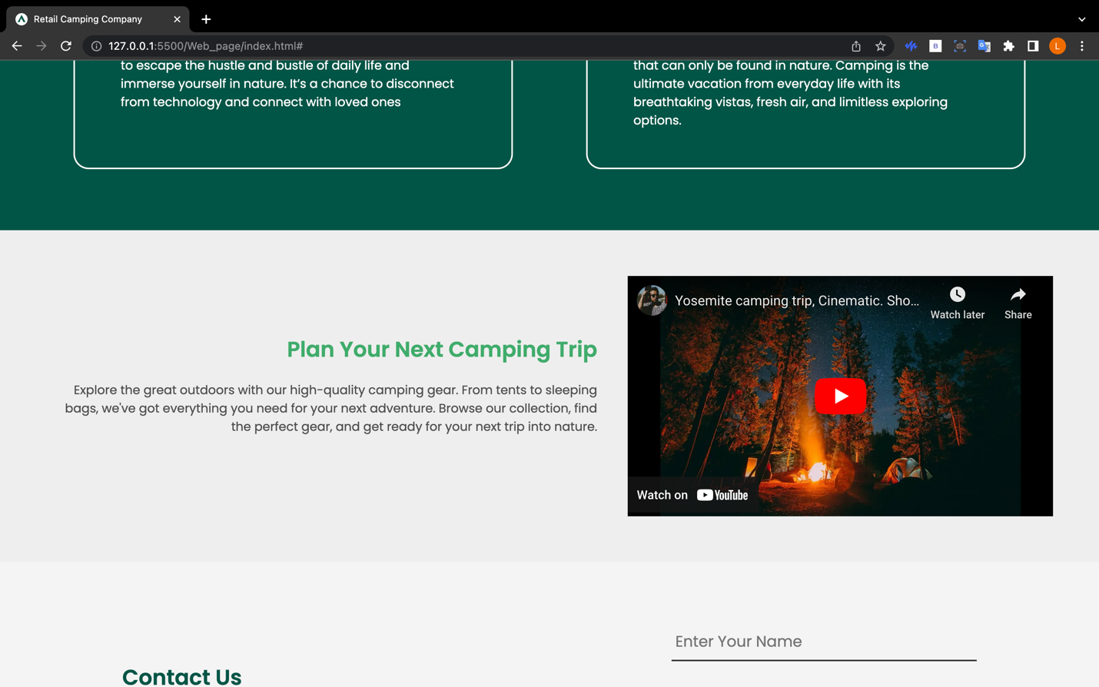

*Fig 31 : Test on Chrome*

Chrome (1344 x 756) – Home page ( YouTube plugin )

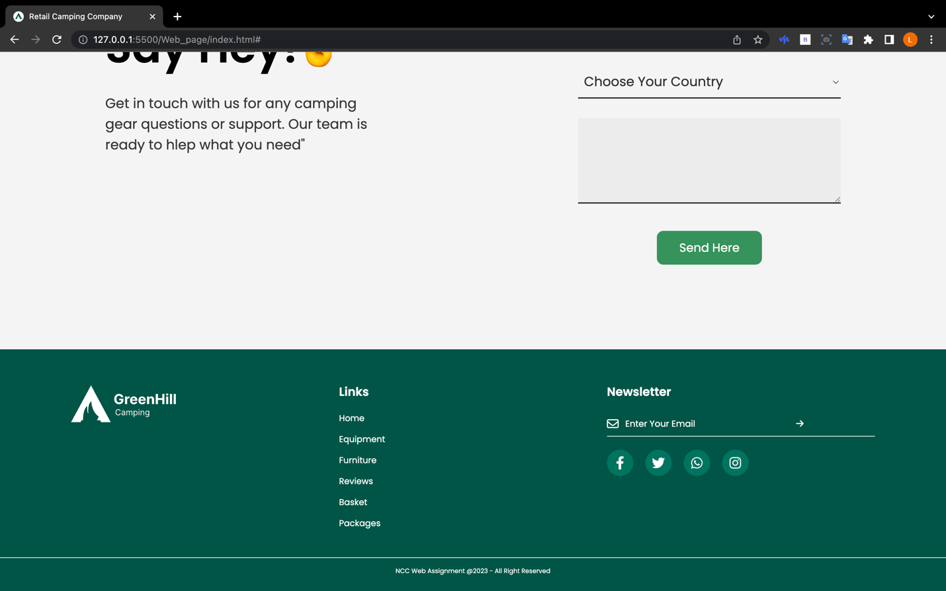

*Fig 32 : Test on Chrome*

Chrome (1344 x 756) – Home page ( Footer )

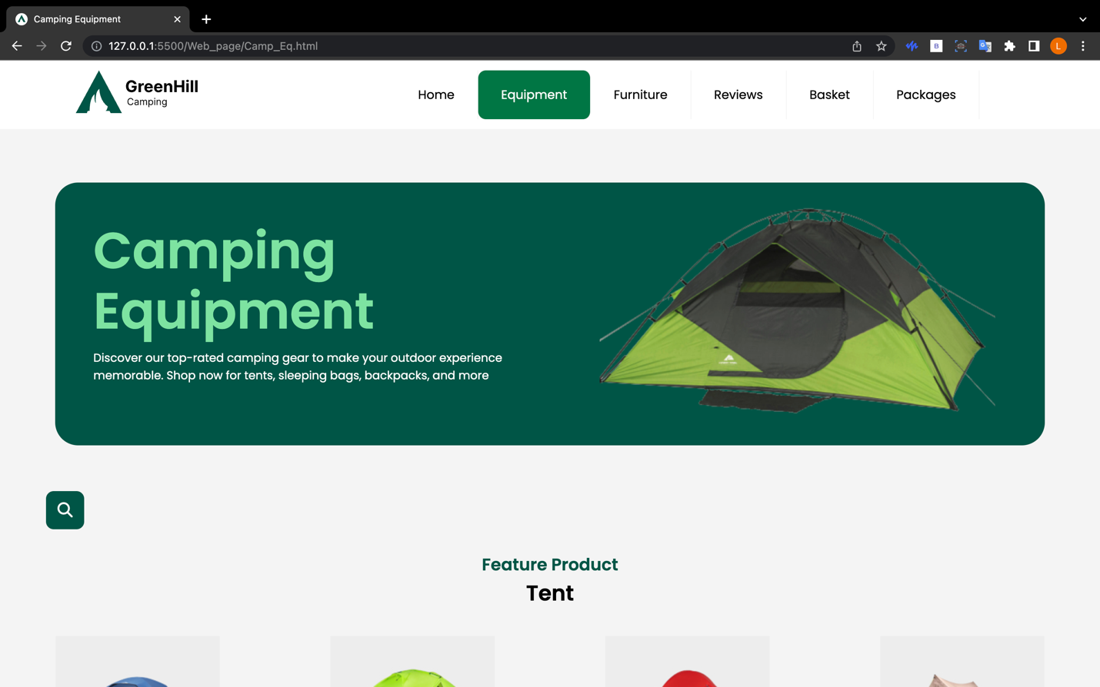

*Fig 33 : Test on Chrome*

Chrome (1344 x 756) – Camping Equipment Page

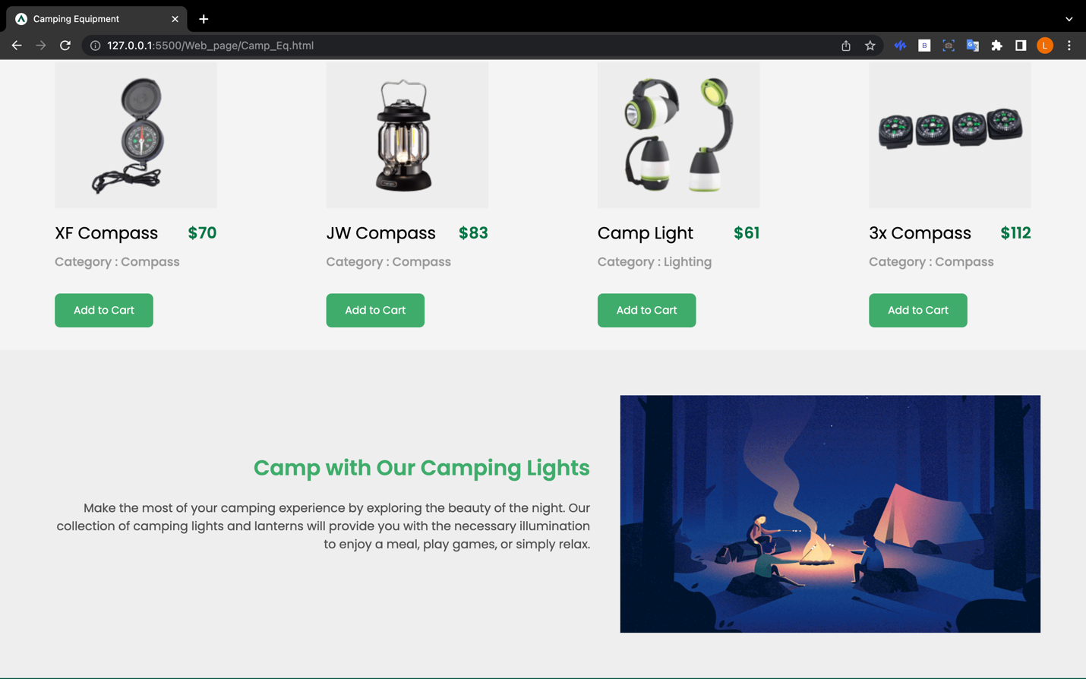

*Fig 34 : Test on Chrome*

Chrome (1344 x 756) – Camping Equipment Page

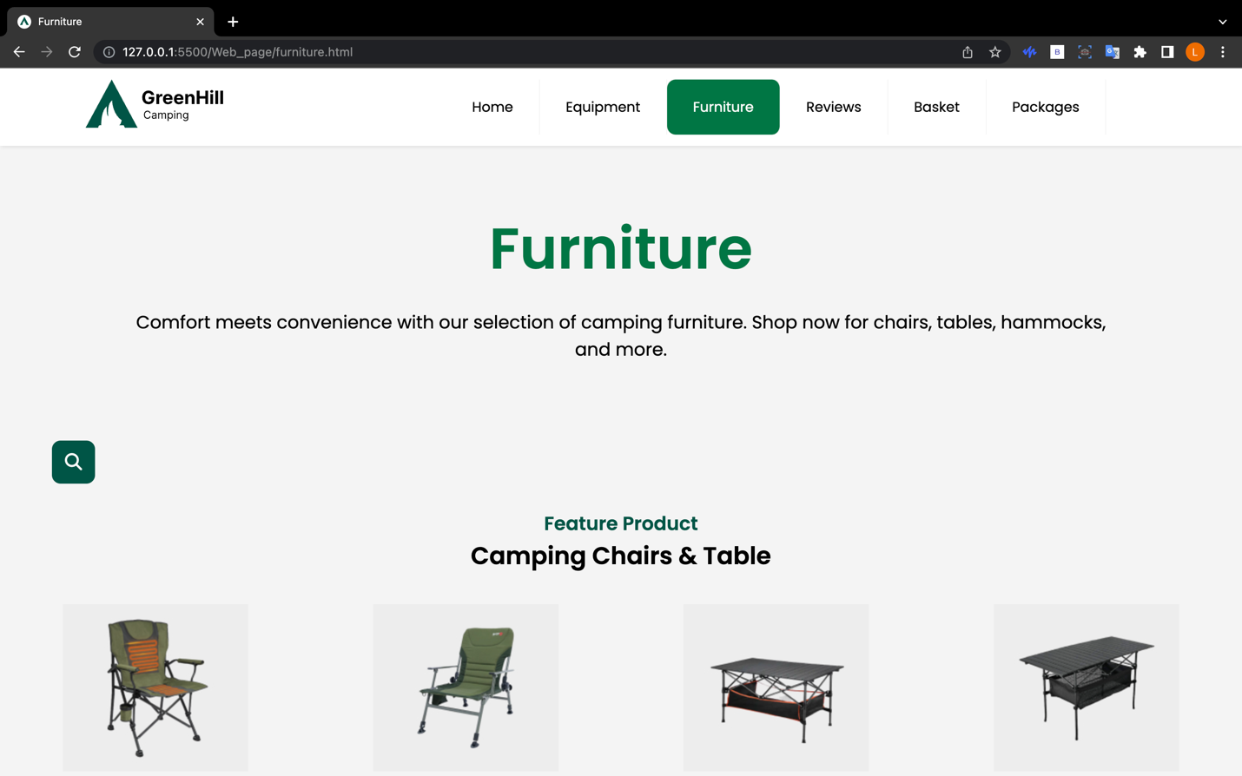

*Fig 35 : Test on Chrome*

Chrome (1344 x 756) – Furniture Page

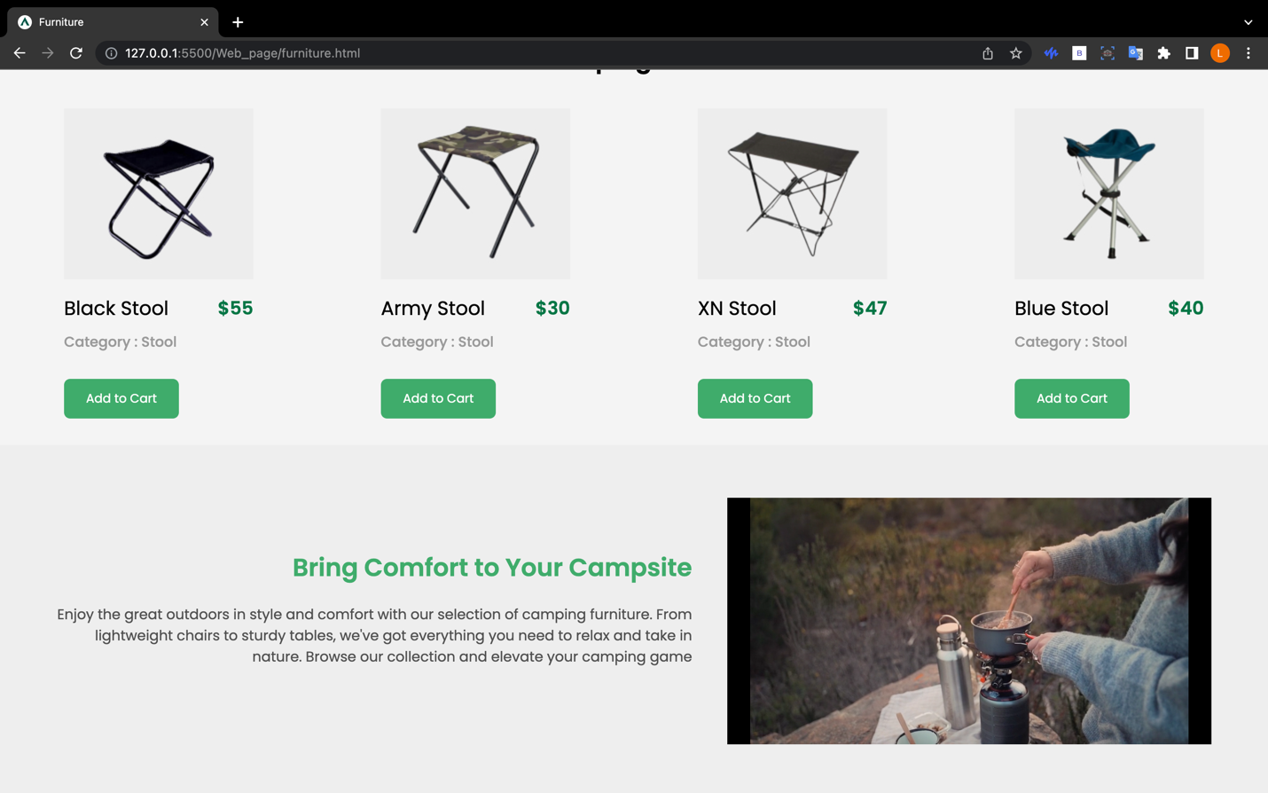

*Fig 36 : Test on Chrome*

Chrome (1344 x 756) – Furniture Page ( video plugin)

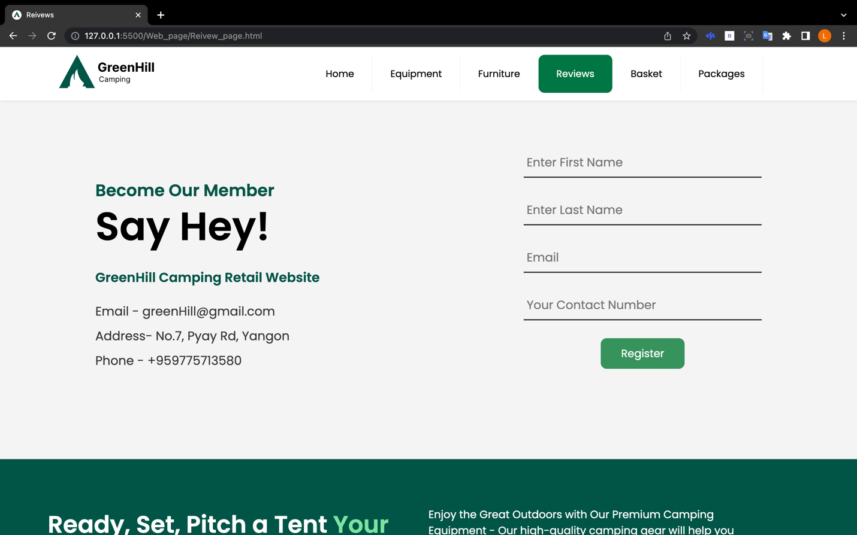

*Fig 37 : Test on Chrome*

Chrome (1344 x 756) – Review Page ( Member register form )

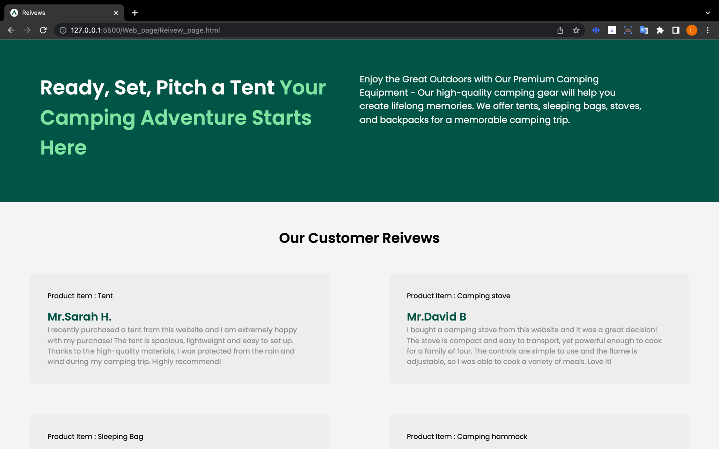

*Fig 38 : Test on Chrome*

Chrome (1344 x 756) – Review Page ( Our Customer Review )

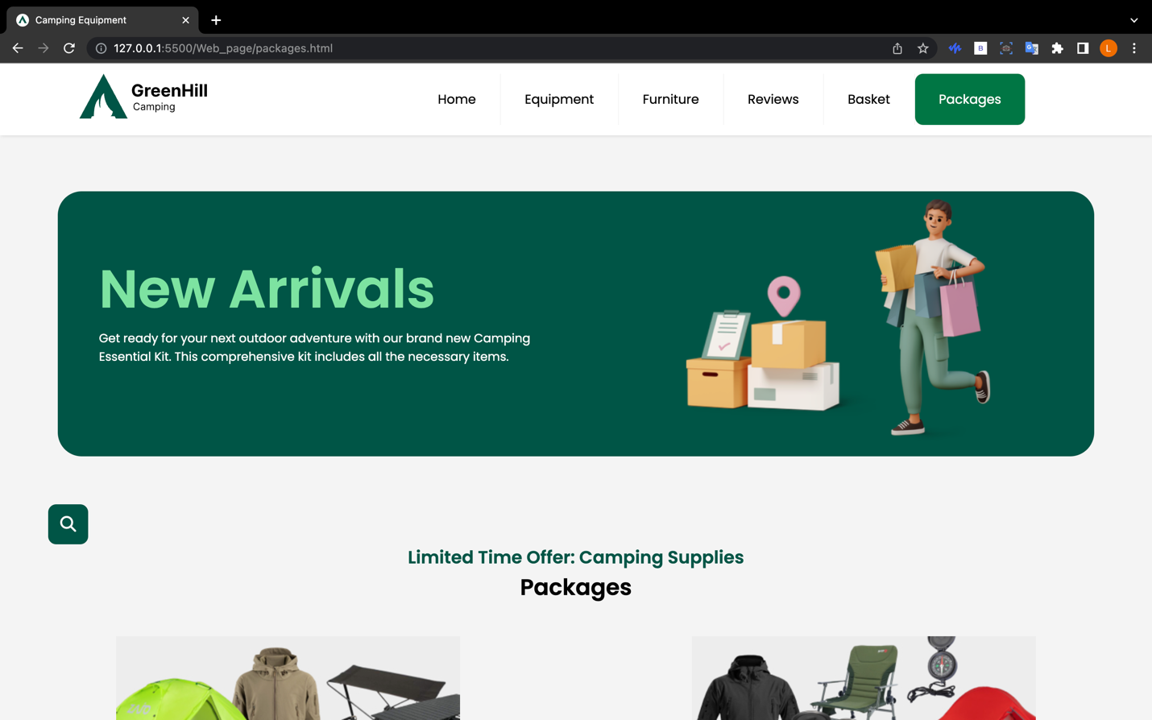

*Fig 39 : Test on Chrome*

Chrome (1344 x 756) – Offer and packages Page

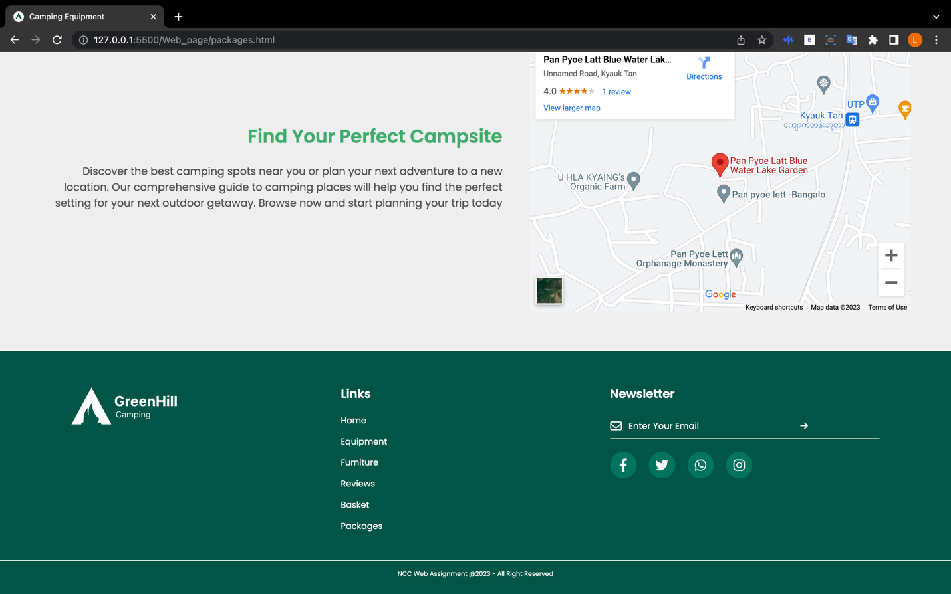

*Fig 34 : Test on Chrome*

Chrome (1344 x 756) – Review Page ( Display Map plugin )

## 3.4 Problems and recommendations for how these could be fixed

When making a responsive design for different screen sizes and devices, I ran into a lot of problems and mistakes with margins, padding, and sections while designing and making the page. The validator at W3C shows an error message at the <img> tag when the HTML file is being checked. It does not allow you to set the width and height of an image with the <img> tag in percentages (%); you can only use numbers. Responsiveness is the most important part of making a website work on multi-media platforms.

### 3.4.1 Solutions for the Problems

Browser inspection helps developers. We can see what CSS properties are used in each element by inspecting it. Browser inspects element helps correct margin, padding, and division errors. I fixed the image problem by giving it a class name and using CSS to change its width and height. One way for a responsive webpage to solve a problem is with a responsive grid view. Most responsive grid views have 12 columns, and the width of the whole thing is 100%. 100% divided by 12 columns = 8.33%, so the width of one column is 8.33%. When making responsive web pages, a grid view is a very helpful tool. The developer finds it easier to put things on the page.

### 3.4.2 The Role of W3C

When the Internet first started to grow, there weren't many standard codes for how pages looked or how browsers could work with them. Before these standards were put in place, many browsers didn't work right with the websites. The goal of the W3C World Wide Web Consortium is to help the web reach its fullest potential. Since its start in 1994, the W3C has been a very important part of Web Development. The five most important principles of developing standards are due process, broad consensus, openness, balance, and transparency. (Alaguharani, 2021)

# Task 4

## 4.1 Three different plugin that I used in my website

**Embed YouTube link**

Embedding a YouTube link in a website makes it easy to add video content, which can be a more interesting and interactive way to share information. It also makes our product review video and channel more visible on YouTube, which could bring more people to our channel and get more people to subscribe to it.

**Provide Video Content for UX**

Video content can give users a more immersive experience, which can keep them on our website longer and keep them interested. Videos can also show how complicated ideas or concepts look, which makes it easier for users to understand and remember information**.**

**Display Map**

Putting a map on our website helps people figure out where is our location , which makes it easier for them to find us and builds trust in our site. A map may assist website visitors discover information or local services and products.

## 4.2 Web application development tools

Chrome DevTools is a set of tools that are help my build websites' front ends. I can make my website better by fixing styling mistakes and looking at changes as they happen. Since developers can modify code and see the results instantly, it's an excellent tool for real-time testing and debugging. (Hameed, n.d.)

WebStorm is an effective IDE that was developed specifically for the process of creating websites. It has intelligent coding support, code quality analysis, and version control integration. WebStorm is a complete tool that speeds up my development process and makes it easier for me to work on assignment projects and write good code. It's a good alternative to Visual Studio Code and other general-purpose IDEs since it's developed for web development.

## 4.3 Two benefits to RCC of using web services

Every business needs a website to promote themselves or their products nowadays . This is the best way to make the network bigger and get a lot of customers' attention. The  Camping Retail Company uses web services, it's because no one has time to go to the store and see what they need. It also takes a lot of time. But with online marketplaces, customers can visit the website, click "Add to Cart," and buy what they need. So much time is saved.

From the perspective of the consumer, they don't have to waste time looking for what they want or need. It also helps the customer understand more about the product based on website content.

From a business perspective, "our product items increased," which is a good thing for running a successful business. If profits are strong, we want to expand our current number of stores in each location to better serve our clients.

## 4.4 Further development of the website

**Improve Speed**

If your home page takes a long time to load, people will never look at the other tabs. And slow websites can hurt their search engine optimization rankings (SEO). A good website makes it easier for people to do things like go to another page. (Campbell, 2019)

**Upgrade to the latest website design with animation**

Modern web design includes animation, which makes a website look more interesting and interactive when people click, hover, or scroll over an element.

Putting animation on a website can get more people to look at it.

In the last few years, VR technologies have been widely used around the world, and many companies have been involved. When we add 3D Product design to our website, it can make it better and more appealing to users. (Kundariya, n.d.)

**Improve website dynamicity and customer service**

When a consumer places an order via our website, they are eligible for our free delivery service. In addition, we will be able to accept online payments using services such as Visa and PayPal.

# Conclusion

This site has been checked by the W3C validation service, and there are no problems with it. In the future, there will be more plans, like Payment, Delivery, selling camping products for kids, and so on. This site has also been tested on different browsers and works with all devices.

# References

Hameed, S. (n.d.). What are Chrome DevTools. [online]

Available at: <https://linuxhint.com/chrome-dev-tools/>

[Accessed 7 Feb. 2023].

Ślusarczyk, A. (2021). Websites with a Green Color Palette That Look Amazing. [online] Be Theme Blog.

Available at: <https://muffingroup.com/blog/green-color-palette/#:~:text=A%20green%20color%20palette%20will>

[Accessed 7 Feb. 2023].

Quora. (n.d.). What is W3C, and why is it important? [online]

Available at: <https://www.quora.com/What-is-W3C-and-why-is-it-important>

[Accessed 7 Feb. 2023].

www.rei.com. (n.d.). Camping Checklist. [online]

Available at: <https://www.rei.com/learn/expert-advice/family-camping-checklist.html>

[Accessed 7 Feb. 2023]

www.globalreach.com. (n.d.). 6 Essential Features Every Website Should Have | Global Reach. [online] Available at: <https://www.globalreach.com/global-reach-media/newsletters/grip-newsletter/global-reach-engage--july-2016/6-essential-features-every-website-should-have>

[Accessed 7 Feb. 2023]

Kundariya, H. (n.d.). Top 10 Web Development Trends to Expect in 2021. [online] blog.hubspot.com. Available at: <https://blog.hubspot.com/website/web-development-trends>

[Accessed 7 Feb. 2023]